

**What can you apply?**

Elderly (60 years and over) and disabled

-October 1

All other households

-November 1

LIHEAP applications are effective for a full

year unless you move to a new home or change suppliers.

 

 

 

 

 

**Questions?**

Call:

**1**

**-**

**855**

**-**

**FSD**

**-**

**INFO**

**(1**

**-**

**855**

**-**

**373**

**-**

**4636)**

Or start a chat on our

website

:

**mydss.mo.gov/energy**

**-**

**assistance**

**LIHEAP**

helps keep families safe and

healthy with assistance for their

energy costs.

**Family Support Division**

**LIHEAP Unit**

**P.O. Box 2320**

**Jefferson City, MO 65102**

**Low Income Home**

**Energy Assistance**

**Program (LIHEAP)**

***Get relief for your***

***energy bills***

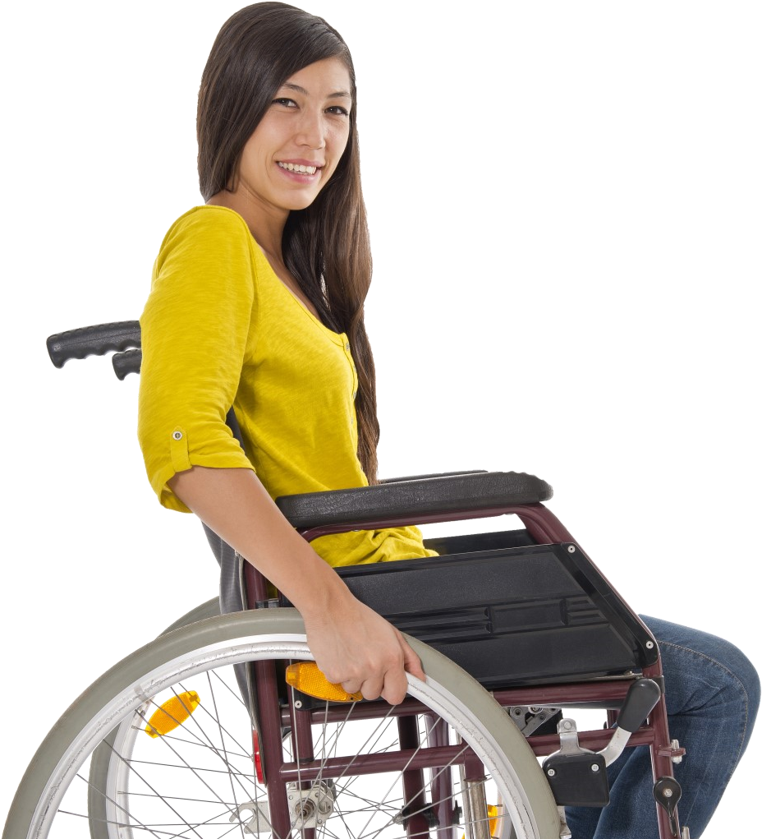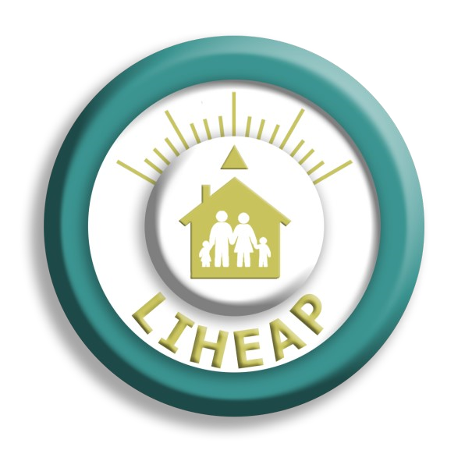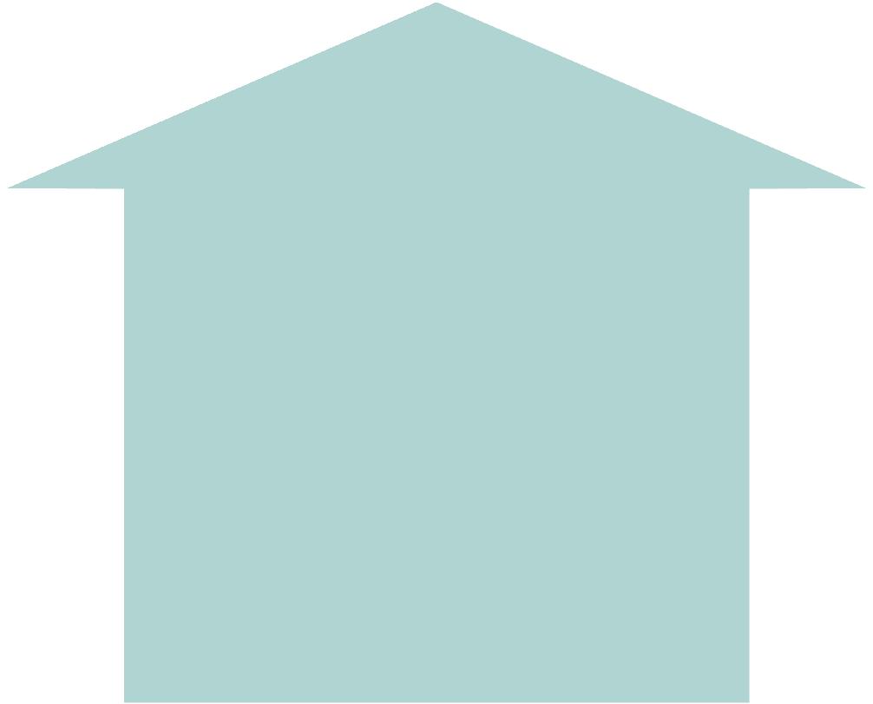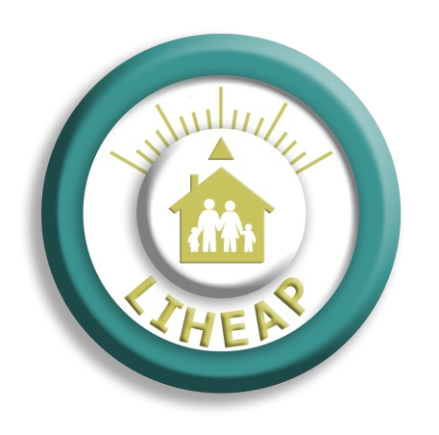

IM

-

4

LIHEAP (Rev.

08/20)

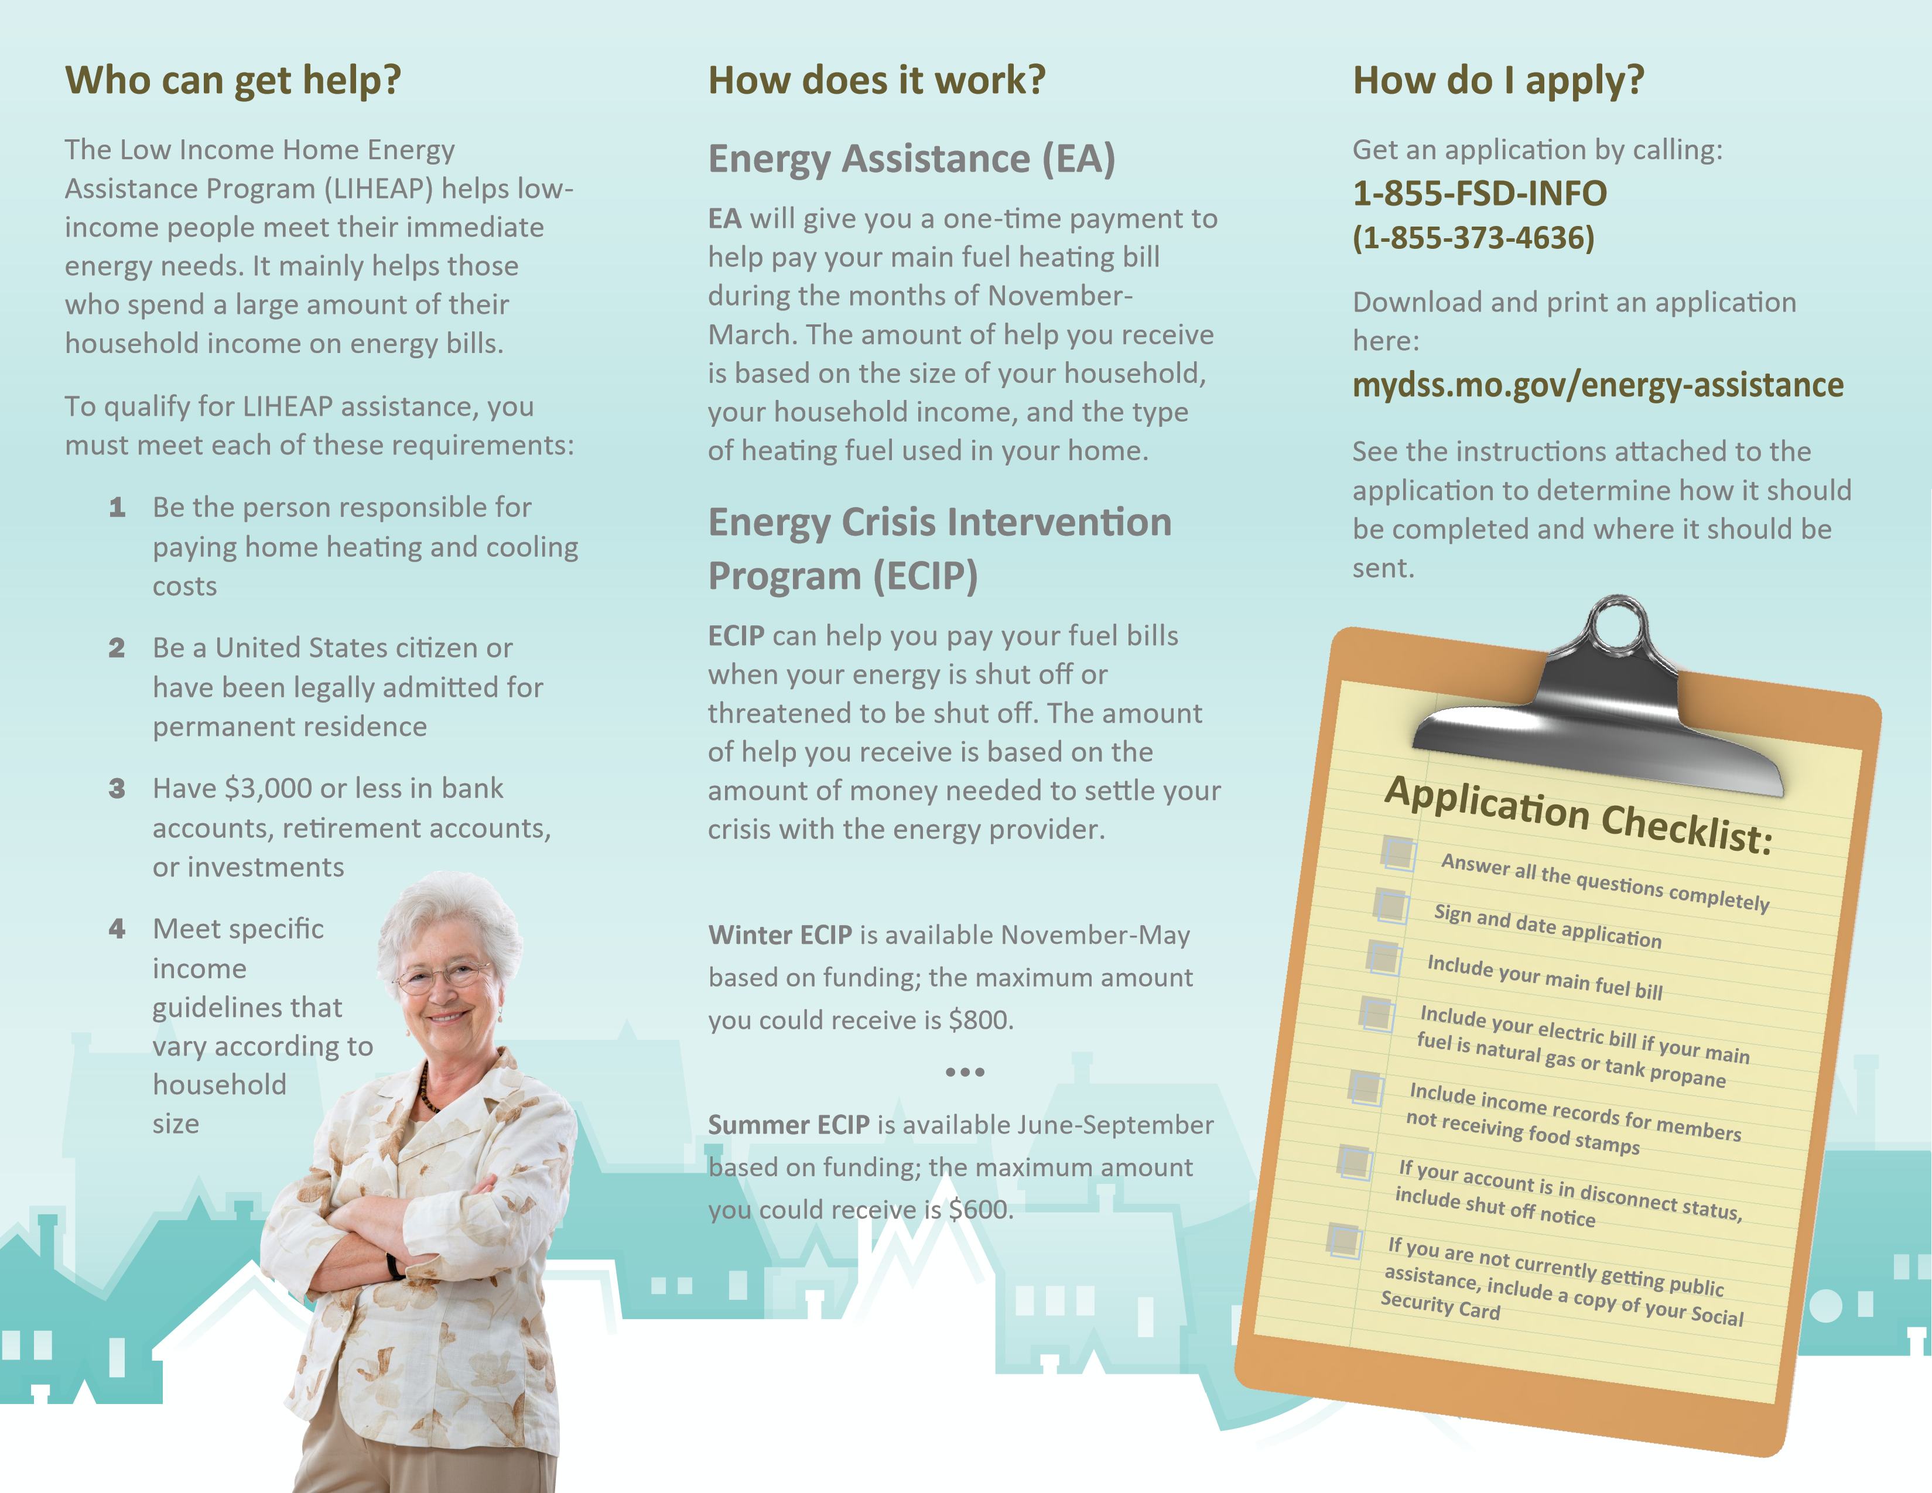

**EA** will give you a one-time payment to help pay your main fuel heating bill during the months of November to March. The amount of help you receive is based on the size of your household, and the type of heating fuel used in your home.

**Energy Crisis Intervention Program (ECIP)**

**ECIP** can help you pay your fuel and electric bills when your energy is threatened to be shut off. The amount of help you receive is the minimum amount needed to the provider.

**Winter ECIP** is available November through May based on funding; the maximum amount you could receive is $800 for fuel and electric help.

**Summer ECIP** is available June through September based on funding; the maximum amount you could receive is $600 for electric help only.